PACKAGES To:

11/20  COSCO SHIPPING SCORPIO 020W 1*40RQ

加拼二十个关单号

FM:JYD 胡金龙

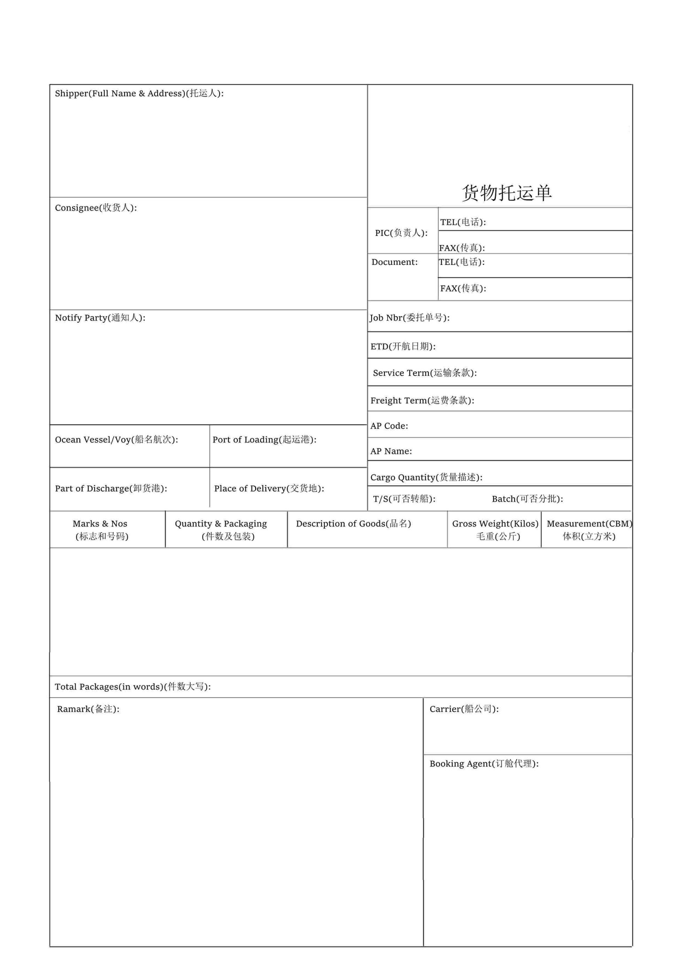

**上海如润风国际物流有限公司**

JYDSEM21080250

胡金龙

上海如润风国际物流有限公司

东方海外货柜航运公司

29

SHANGHAI JIYIDA INTERNATIONAL LOGISTICS CO.,LTD\N RM1304-1306,BULIDING A,HESHENG FORTUNE PLAZA,\N NO.839 DALIAN RD, HONGKOU DIS,SHANGHAI,CHINA\N TEL:021-63930701\N FAX:021-63930650

ALFONS KOESTER & CO GMBH

GLOBAL FREIGHT LOGISTICS

BEIM STROHHAUSE 2

20097 HAMBURG GERMANY

TEL:+49/40/2 84 24-245

FAX:+49/40/2 84 24-286

SAME AS CONSIGNEE

SHANGHAI

HAMBURG

HAMBURG

TOTAL:TWENTY NINE(29)PACKAGES ONLY.

PP

40RHX1

40RHX1

021-63930701

13411KGS

54.942CBM

CY-CY

256

COSCO SHIPPING ARIES V.V.018W